CT Baseball - Coaches Practice Playbook – Practice 2
Coaches Reminder – In addition to this practice plan, refer to the CT Baseball drill library to help customize based on the skill level of your team and desired focus areas.
Pre-Practice Huddle (5 minutes):
- Rule review – Young Teams - Review the number of strikes/pitches in an at bat and 3 Outs per half inning. Older teams - review rules around stealing bases, specific to the age group (lead offs, dropped third strike, etc.)
Warm Up/Partner Skill Building (20-25 minutes):
- Follow the CT Baseball – Suggested Warm Up Routine guidelines
Stations (30-40 minutes):
- Divide players equally into groups – suggest 3-4 stations total depending on the number of assistant coaches/parent helpers. You can also split the team into two groups and change the stations after two rotations (for a total of 4 stations).
- Station 1 – Outfield - Suggested Drill – Break Down (Easy): This drill is practice proper fielding technique for ground balls in the outfield. Fielder should stand in the outfield facing the coach. The coach will stand about 40 feet away and hit balls to the first fielder in line. The fielder should approach the ball, then drop their throwing side knee to the ground and put their glove between their legs to field the ball. The player should then rise, crow hop and throw back to the coach. Once this is mastered, you can have your players scoop the baseball when you’re attempting to aggressively throw out a runner (field next to your glove side foot, crouched and ready to hop).
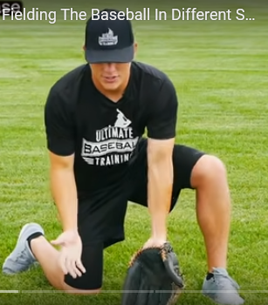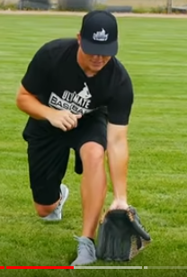
- Station 2 – Infield - Suggested Drill – Infield Combo Drill (Easy): This is a good drill to generate a high number of key repetitions quickly. Start with the fielders in a line with gloves on and a ball in their glove, about 20 feet from the coach. The first player will throw the ball to the coach. The coach will throw a ground ball to the player. The player will field it and throw it back to the coach. The coach will then throw a short pop fly to the player. The player will catch it and make a strong throw back to the coach. Finally, the coach will bounce a slow roller to the player, who will field it (usually bare handed). The player will then take the ball and get in line behind the coach. Each player will rotate through until all players are behind the coach. The drill can start over again if desired by having the coach walk to reestablish the 20 foot distance to the player line and rotate through the order again.
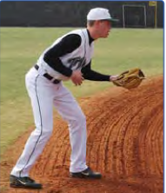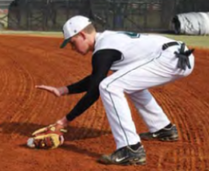
- Station 3 – Hitting - Suggested Drill – Balance Beam Drill (Easy): Lay a 2x6 piece of lumber on the ground and have the player swing off the tee or soft toss. The player’s heels may hang off the edge a bit. Have the player do whatever they can to stay on the beam after finishing the swing.
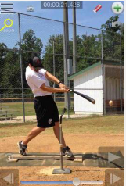
- Station 4 - (Optional) Pitching/Throwing - Suggested Drills
Waltz (Easy): This drill is good for timing, coordination and balance. Players can stand anywhere on the field. No baseball is required. Have the players gather on their normal pivot foot, with hands in the center of their body, then hop to their stride foot. Balance on the stride foot and hop back to the pivot foot. Repeat this 15-20 times.
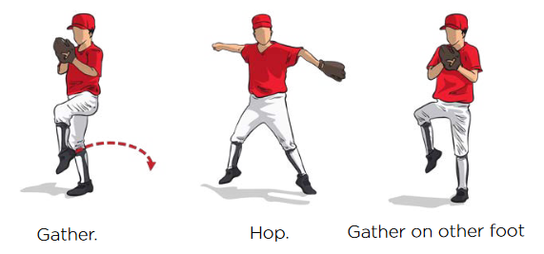
Pivot Foot Hop (Easy): Line pitchers up with partners, gloves on, and a baseball for each set of partners. The drill begins with the player taking their rocker step, pivoting and getting their foot parallel to the rubber. The pitcher will bring their stride leg up in a controlled motion, then he will hop three times on his pivot foot only. After three hops, he can stride and deliver the baseball to his partner. The idea is establish a good balance point on the pivot foot, and team the pitchers to coil and launch off of the pivot foot to accelerate the hips and lower body with the throw.
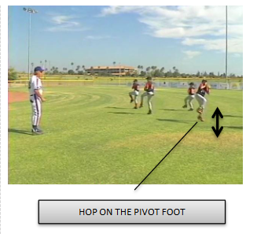

- Players will spend about 10 minutes at each station before rotating to the next
Water Break + Huddle (5-10 Minutes):
- Word of the Week – Hard Work
  - "There may be people that have more talent than you, but there's no excuse for anyone to work harder than you do." Derek Jeter
  - Working hard is a habit. Habits are the decisions we make every day.
  - Everyone plays like how they practice, so if you want to play well, you have to practice doing the right things over and over again, and choose to do it with intensity.
  - Team Building Activity of the Week – 20 Questions. “I’m thinking of a famous baseball player that worked hard for years to make it as a pro. You have 20 questions to see if you can figure out who it is!”
- Team Activity (25-30 Minutes):
- Suggested Drill – Race to Home
Fun Activity (5 Minutes):
- Baseball Bucket Toss – Players line up on the mound and attempt to hit a bucket of balls sitting at home plate. Every time they hit the bucket, a coach selected by the player has to run to the fence and back.
Post Game (2 minutes):
- Remind players of next upcoming practice and any details regarding schedule and uniform distribution
- Encourage teammates to practice at home with parents, guardians or friends

