CT Baseball - Coaches Practice Playbook – Practice 4
Coaches Reminder – In addition to this practice plan, refer to the CT Baseball drill library to help customize based on the skill level of your team and desired focus areas.
Pre-Practice Huddle (5 minutes):
- Rule review – Review what is a foul or fair ball. A ball that touches any part of the line is fair. A ball touched in the air in fair territory on the infield is a fair ball, a ball touched in the air in foul territory on the infield is foul – it’s where the ball is, not the player. A ball that starts foul can roll fair before it reaches the base or a ball that’s fair can roll foul. Bases are part of fair territory, including home plate!
- Discuss what went well/not so well in recent games/practices
Warm Up/Partner Skill Building (20-25 minutes):
- Follow the CT Baseball – Suggested Warm Up Routine guidelines
Stations (30-40 minutes):
- Divide players equally into groups – suggest 3-4 stations total depending on the number of assistant coaches/parent helpers. You can also split the team into two groups and change the stations after two rotations (for a total of 4 stations).
- Station 1 – Hitting - Suggested Drill – Hook Em’s (Medium): Have the hitter begin with their front foot over top of their back foot. They will load, coil on the back hip, then stride and complete their swing explosively. This drill is to focus on using the bottom half of the body to generate controlled rotational force on time.
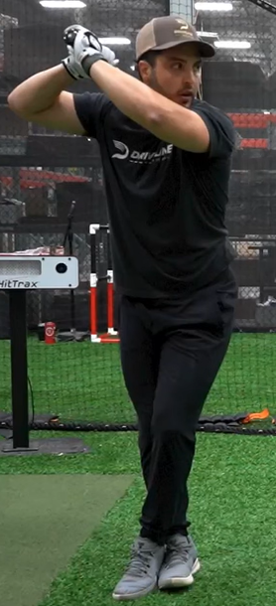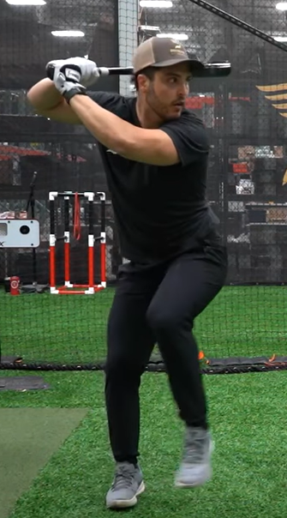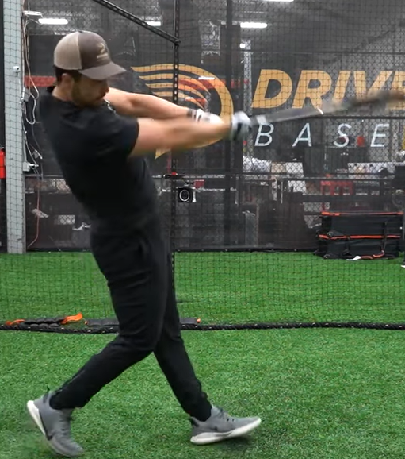
- Station 2 – Infield - Suggested Drill – Underhand Flip Force Outs (Easy): This drill is to practice using the underhand flip to get force outs at second base. Make two lines of players, one at shortstop, one at second. Coach stands with a bucket of balls at the mound or home plate. Roll or hit a ball to the short stop. Second basemen should cover the base and reach with his right foot to the throw. Flips should be done in the bare hand, with the receiver clearly able to see the throwing hand. Flipper should step towards the target and follow through by pointing directly at the target (explain that they should be reaching out like they are “shaking hands” when they finish the flip. Flip should be relatively firm, but not fast. When complete, rotate to the next pair. You can alternate the drill by hitting to the second basemen with the shortstop covering. An advanced version of this drill would also have a player on first base and practice turning double plays.
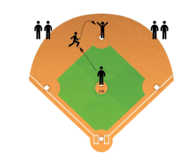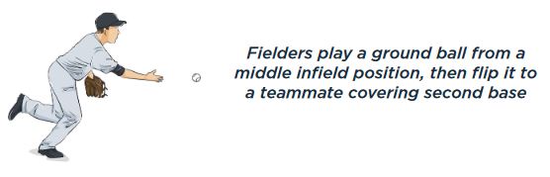
- Station 3 – Outfield - Suggested Drill – Wide Receiver (Easy): The coach lines up as a quarterback with a bucket of balls and a line of players 10-20 feet to their left. On the coach’s signal, the players sprint downfield and then turn in on a 45 degree angle to make a “post” pattern. Just after the turn, the coach will throw a fly ball to the player. After the player completes their attempt, they line up on the other side of the coach. Once all players are done on the left side, the coach will throw post patterns with the players coming from the right side. The drill is complete when all players have gone on both sides. You can make this drill easier or harder by having the patterns closer or further away.
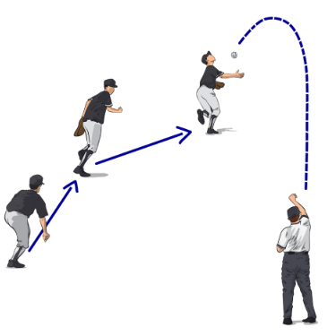
- Station 4 - (Optional) Pitching - Suggested Drill – Pitch Grips: Explain pitch grips to players. Have players partner up and throw a bull pen session to each other, experimenting with throwing balls with different grips (concentrate on 4 seam/2 seam (sinker) grips for young players, include change ups, curve balls and cutters for older players). See the CT Baseball Drill Library on Pitch Grips for reference, as needed.
- Players will spend about 10 minutes at each station before rotating to the next
Water Break + Huddle (5-10 Minutes):
- Word of the Week – Sportsmanship
  - "Sometimes you win, sometimes you learn.” John Maxwell
  - Win with class, lose with pride. Have a good time and understand you’re learning, even if you aren’t always winning. Baseball is a game and it’s supposed to be fun, regardless of the outcome.
  - If you win, make sure your opponent still wants to compete with you next time.
  - Team Building Activity of the Week – Brainstorm – Each player should think of and share a way they can show good sportsmanship
- Team Activity (25-30 Minutes):
- Suggested Drill – Doubles (Under Outfield Drills in the CT Drill Library)
Fun Activity (5 Minutes):
- Pin Ball – Players take turns trying to knock over a stack of buckets (or other target) by hitting baseballs off of a tee or soft toss
Post Game (2 minutes):
- Remind players of next upcoming practice and any details regarding schedule and uniform distribution
- Encourage teammates to practice at home with parents, guardians or friends

